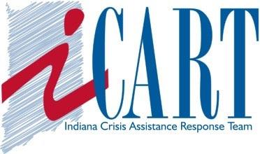
Indiana Crisis Assistance Response Team Sponsoring
Advanced Community Crisis Response Team Training
Registration Form

**prerequisite - you must have completed the NOVA BASIC CRT training
March 16, 17 & 18, 2023
Class Time: 8:30 a.m. - 5:30 p.m. EST
Location: Moorhead Resource Center
8400 E 10th Street, Indianapolis 46219
$295 – Early Bird Special $250 by 2/17/23
To register, please complete this form and submit it to I-CART via email (indianacrisisresponseteam@gmail.com), or mail (PO Box 501285, Indianapolis, IN 46250-6285).
Payment can be sent to: paypal.me/INCart911 Scholarships may be available upon request.
Act NOW! Registration deadline is Wednesday, March 8, 2023

First Name: ___________________________ Last Name: ________________________

Organization: ____________________________________________________________

Mailing Address: _________________________________________________________

_________________________________________________________________________

Email Address: __________________________________________________________

Alternate Email Address: __________________________________________________

Phone Number: __________________________________________________________

MEAL NEEDS: __________________________________________________________

I-CART reserves the right to cancel any training due to lack of minimum registration of 18 registrants. Max. 25 participants.

